1. Remove and Re-insert (Reseat) the RAM Module
Procedure:
- First, shut down the computer properly.
- Disconnect the power cable and all connected devices.
- Open the desktop cabinet or laptop back cover using a screwdriver.
- Locate the RAM slots on the motherboard.
- Push the RAM slot clips outward gently to release the RAM module.
- Carefully remove the RAM module by holding its edges.
- Check the RAM module for dust or physical damage.
- Re-insert the RAM module in the correct direction.
- Press gently until the clips lock into place.
- Close the cabinet or laptop cover and start the computer.
- Check whether the computer starts normally.
Observation:
- RAM was successfully removed and re-inserted.
- No physical damage was observed.
- RAM was properly fitted into the slot.
- The computer started successfully.
Conclusion: RAM reseating was completed successfully, and the computer worked normally.
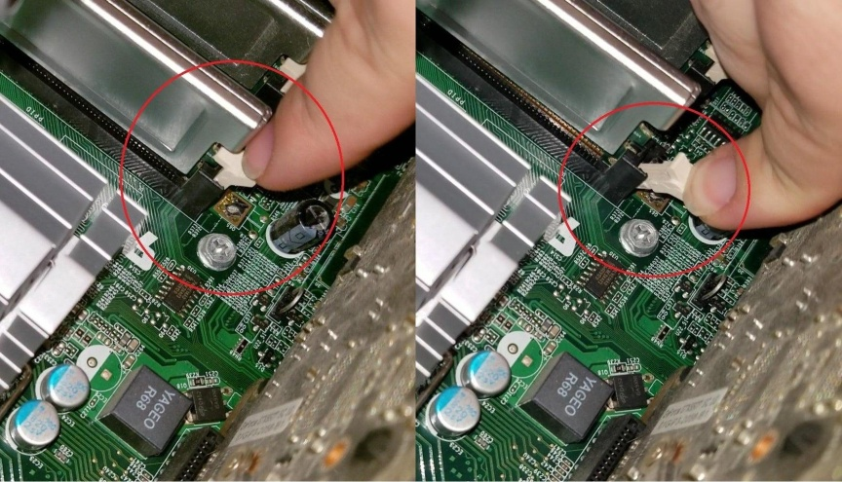

2. GPU Troubleshooting Checklist
A GPU (Graphics Processing Unit) is responsible for processing graphics and displaying images on the monitor. The following checklist helps diagnose GPU-related problems.
Troubleshooting Checklist:
- Check Display: Make sure the monitor is turned on and the display cable is properly connected.
- Check GPU Power: Verify that the GPU power connectors are properly connected.
- Check Physical Connection: Ensure that the GPU is properly fitted into the PCIe slot.
- Check Drivers: Open Device Manager and check whether the graphics driver is installed correctly.
- Update Drivers: Update or reinstall the graphics driver if any error is found.
- Check Temperature: Monitor GPU temperature to identify overheating problems.
- Test GPU: Run a graphics test or game to check GPU performance.
- Confirm the Fix: Restart the PC and verify that the display works properly without errors.
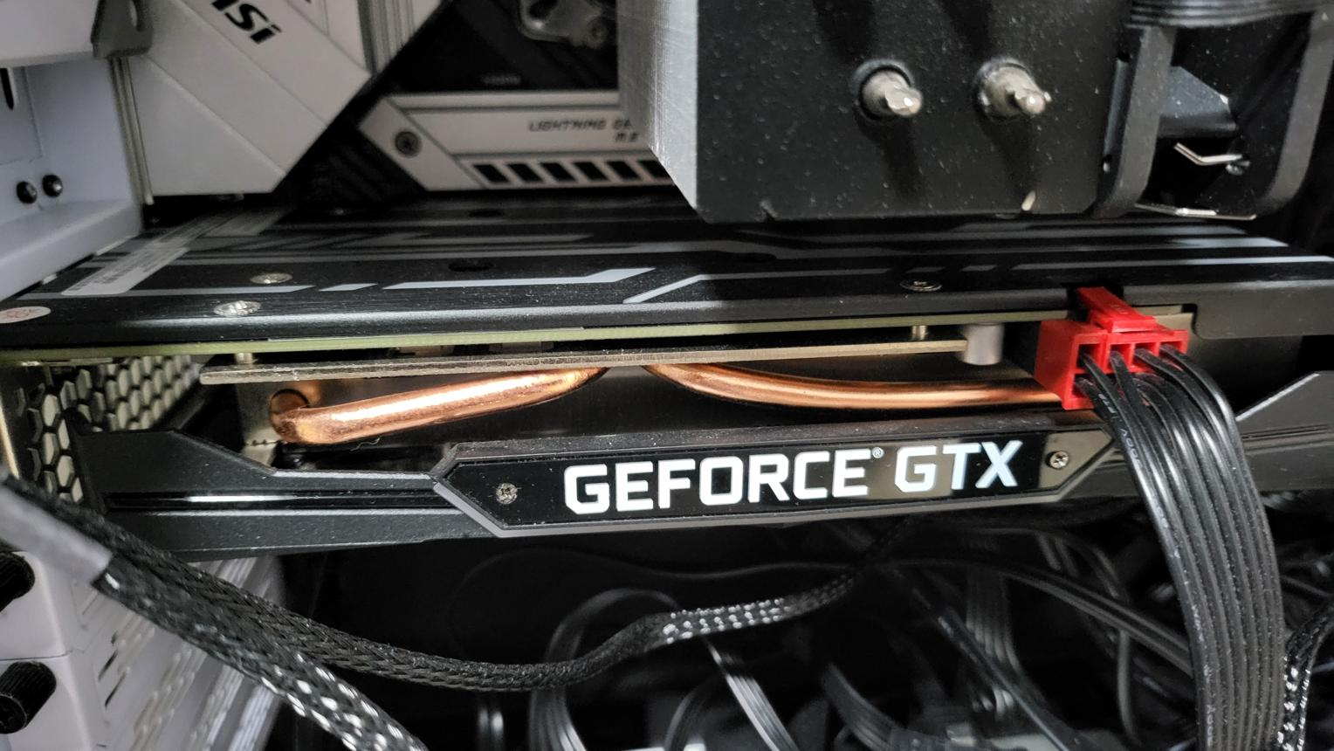

3. Simulate a Storage Issue by Disconnecting and Reconnecting a Drive
To understand how a computer behaves when an SSD or HDD is disconnected and reconnected.
Procedure:
- Shut down the computer and unplug the power cable.
- Open the computer cabinet.
- Locate the SSD or HDD.
- Disconnect the SATA data cable and power cable from the drive.
- Start the computer and enter BIOS/UEFI settings.
- Check whether the storage drive is detected or not.
- Shut down the computer and unplug the power cable again.
- Reconnect the SATA data and power cables properly.
- Start the computer and enter BIOS again.
- Check whether the storage drive is detected.
Observation:
Before Reconnection | After Reconnection
Drive may not be detected in BIOS. | Drive is detected in BIOS.
Boot device not found error may appear. | Operating system starts normally.
Storage information may be missing. | Storage information is displayed.

Possible Error Messages:
- No Bootable Device Found
- Operating System Not Found
- Boot Device Not Found

4. PC Randomly Restarts – Which Component Would You Check First?
Scenario: A PC randomly restarts while working or playing games.

I would check the RAM (Random Access Memory) first because faulty or loose RAM can cause unexpected restarts, system crashes, and blue screen errors.
Diagnostic Steps for RAM:
1. Check RAM Connection: Shut down the PC, unplug the power cable, and check whether the RAM module is properly fitted.
2. Reseat the RAM: Remove the RAM module carefully and insert it again into the RAM slot.
3. Check for Dust: Inspect the RAM slot and module for dust or damage. Clean only with appropriate safe methods.
4. Test One RAM Module: If multiple RAM sticks are installed, test one stick at a time to identify a faulty module.
5. Change RAM Slot: Try another compatible RAM slot to check whether the slot is faulty.
6. Test the Computer: Start the PC and check whether it restarts again.
7. Check the Result: If the PC works normally, the issue may have been caused by a loose or faulty RAM connection.
Observation:
- RAM was checked and reseated.
- No physical damage was observed.
- The computer started normally after reseating.
- Random restarting stopped in this sample test.

